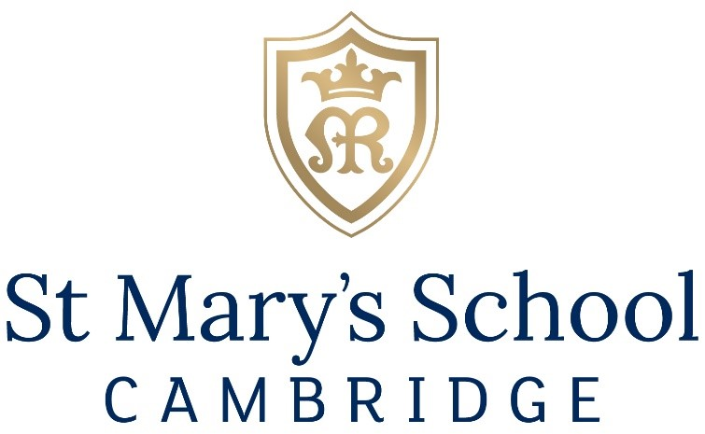

Assistant Rowing Coach
SEPTEMBER 2021
Part-time (10-14 hours per week)
£20 per hour

St Mary’s School, Cambridge is an independent day and boarding school for girls aged 3 to 18.

Situated in the heart of the academically and culturally vibrant city of Cambridge, we are a school where any girl can thrive and achieve academic excellence. A Christian school run in the Catholic tradition and founded on the principles of Mary Ward, we have a unique approach to education and an atmosphere which fosters a love of life and learning.

St Mary’s is looking for an experienced Assistant Rowing Coach to assist the School’s rowing co-ordinator in the implementations and running of the School’s rowing squad.
The successful candidate should be able to coach the School’s rowing squads, of all levels from Learn to Row up to National level rowing and assist with administrative duties as required.
This is a part-time role working for 10 to 14 hours a week term-time only. Additional hours will be required for activities such as summer training camp during the school holidays and away regattas.

Further information can be found on our website https://www.stmaryscambridge.co.uk/about/job-vacancies.htm

Closing date for applications: 9:00am 22nd September 2021
Interviews to be held the shortly after on a date to be confirmed

We will review applications on receipt. Suitable candidates may be interviewed before the closing date and we reserve the right to withdraw the position if an early appointment is made.

The School is an equal opportunities employer. We are committed to safeguarding and promoting the welfare of children and young people and expect all staff and volunteers to share this commitment. Successful applicants are subject to an enhanced DBS check.

Registered Charity No. 290180

Telephone 01223 224144
Email: HR@stmaryscambridge.co.uk

