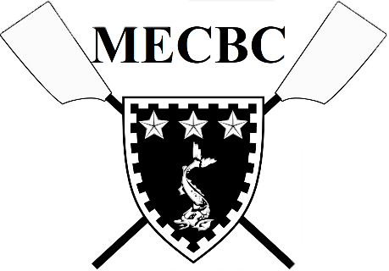

Job Title: Head Coach
Role:
Murray Edwards College Boat Club is seeking an experienced head coach to train our top crew and aid with the development of the squad as a whole.
After losing our head coach in 2019, Medwards’ crews have mainly been coached by student volunteers and have struggled to find continuity in coaching across the club. As a result, we are keen to create a new, more coordinated training programme across the squad and are looking for a new head coach to help us achieve this goal.
Key Duties:
- Coaching our W1 crew involving 3 morning outings during the week and one over the weekend
- Responsible for setting a training programme for the whole squad and developing an overall strategy
- Setting crews alongside club captains and other coaches at the start of each term
- Working with club captains and other coaches to achieve an increase in the depth of the squad and a more structured training programme for all crews
Experience:
- Previous experience as a coach, particularly on the Cam and with experience/knowledge of college rowing and racing
Salary:
- Previous coaches have been paid £25 per session but this may be negotiable depending on experience

If interested, please contact Izzy Rhodes (ir304@cam.ac.uk) for more information.

