Captains Survey results
Please click on the section to expand and view summary results.

Clubs responded & email:
pembroke.men@cucbc.org | Pembroke
clarehall.captain@cucbc.org | Clare Hall
clare.women@cucbc.org | Clare
stcatharines.men@cucbc.org | St Catharines
kings.men@cucbc.org | Kings Men
kings.women@cucbc.org | King's
queens.captain@cucbc.org | Queens' College Boat Club
churchill.captain@cucbc.org | Churchill
hughes.women@cucbc.org | Hughes Hall
selwyn.men@cucbc.org | Selwyn
lucycav.women@cucbc.org | Lucy Cavendish
peterhouse.captain@cucbc.org | Peterhouse Boat Club
hl520@cam.ac.uk | Christ's
ef408@cam.ac.uk | Christ's
ct557@cam.ac.uk | Trinity Hall Boat Club
corpus.captain@cucbc.org | Corpus
caius.captain@cucbc.org | Caius Boat Club
sk993@cam.ac.uk | Fitzwilliam College
dpc46@cam.ac.uk | Jesus
wolfson.men@cucbc.org | Wolfson College
president@girtoncollegeboatclub.com | Girton College Boat Club
captain@firstandthird.org | First and Third
ae458@cam.ac.uk | Murray Edwards
womens.captain@girtoncollegeboatclub.com | Girton College Boat Club
emmanuel@cucbc.org | Emmanuel
hlb54@cam.ac.uk | LMBC
ab2208@cam.ac.uk | Downing College Boat Club
ncbc.captain@gmail.com | Newnham

How many senior rowers do you expect to have this term:
1-10 | Clare Hall, Lucy Cavendish,
11-20 | St Catherines, Kings, Selwyn, Corpus, Fitzwilliam, Wolfson
21-30 | Hughes Hall, Peterhouse, Christs, Murray Edwards, Newnham
31-39 | Clare, Queens, Churchill, Girton, Emmanuel, LMBC
40+ | Trinity Hall, Caius, Downing, First and Third, Jesus, Pembroke

Motivation to continue rowing and use of IV/VIII
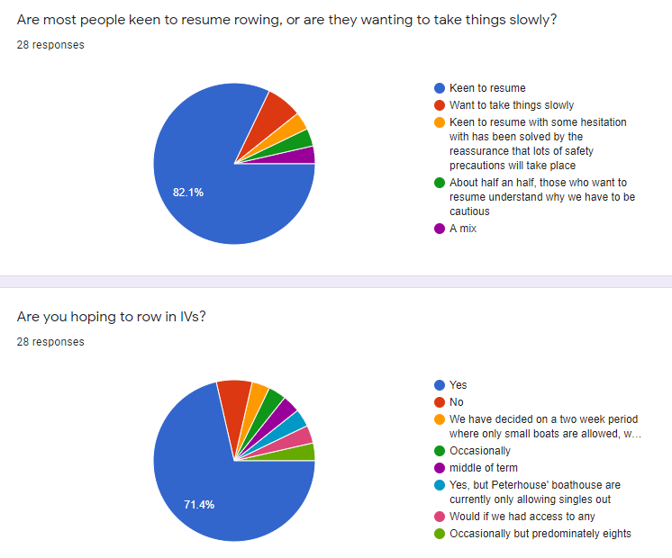
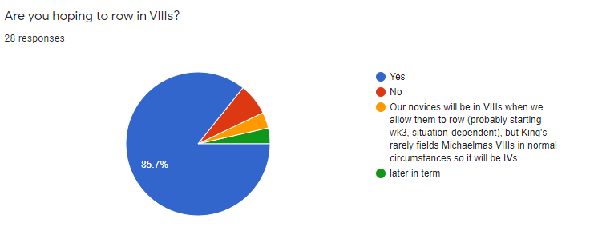

Outing timings and flexibility for daytime outings
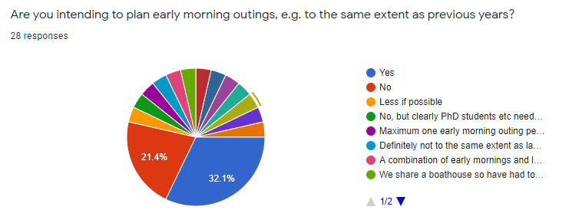
Pertinent comments on early morning outings:
- Postgraduates students and PhD students may have labs which will restrict some crews to early mornings
- Those sharing boathouses may have to restrict number of morning outings to control numbers at BH

Do you think that you will have more flexibility for daytime outings? If so do you intend to spread outings throughout the day?
Pertinent comments on having more flexibility for daytime outings
24 indicated Yes- intending to spread out more due to remote teaching deliveries, safety reasons and to reduce numbers at BH. Will be dependent on logistics and availability, especially those e.g. who need to be in the lab in the day.
3 indicated No- graduates with no daytime flexibility and limited availability of coaches.
1 indicated they were not sure, due to issues of lecture timing.

All responded have contacted college authorities

College responses to Boatclubs, happy to follow BR advice?
Broadly happy to follow BR advice
We have gotten approval for sculling. Will ask about IVs soon, but not that optimistic. They want to take things very slowly, which is understandable. So probably stricter than BR.
Follow BR advice
Happy to follow BR advice
Slightly stricter than BR for the beginning of term
Yes- we have made the decision ourselves to be stricter than BR regulation based on outbreaks in other unis, and sharing a boathouse
Broadly happy for us to follow BR guidelines
Happy to follow BR advice,
Yes
No college response to risk assessment yet
BR guidelines agreed for water sessions; they seem to be being stricter in terms of land training (access to ergs has been heavily reduced)
Stricter, they expect every single thing to be approved, and they don't approve everything easily.
Happy to follow BR advice.
All plans have to be in line with college rules as well as BR ones
Yes, we had to write a plan which was approved by the college executive body
Happy for us to row if following BR, NHS and Government guidelines
A little stricter than BR
BR advice, but Boatman is taking things more conservatively (not in crewed boats immediately etc)
They are happy for us to go ahead with BR advice, but the rules are under constant review and can be changed by the college bursar or other college authorities with little/no warning
most of our rules are following British Rowing
Stricter: only fours
They have agreed to training in groups of 4
They're applying their own rules, but are generally inline with BR
Happy for us to follow BR advice.
Slightly stricter than BR, but just about manageable
Stepping up into larger boats later in the term
They are happy for us to follow BR guidelines (with a lot of safety and cleaning precautions and a very strict subs policy)

Race intentions, seniors:
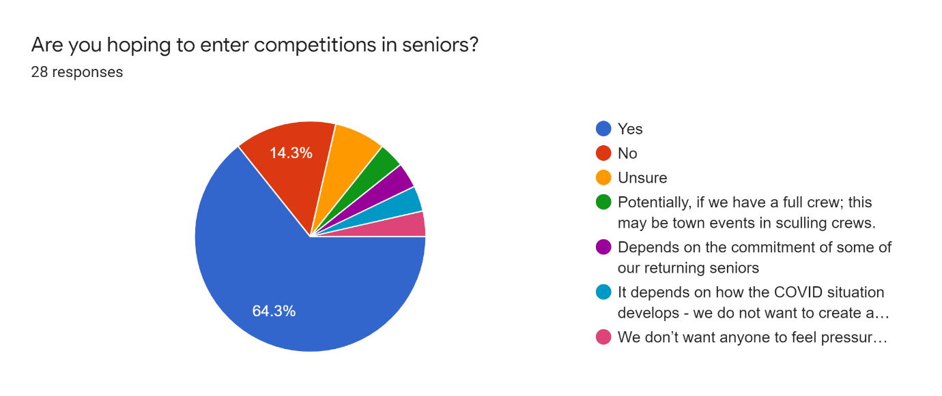

We don’t want anyone to feel pressured to meet a certain standard for racing so it depends on the nature of the races and what we feel prepared to do, but we’re cautious
It depends on how the COVID situation develops - we do not want to create an environment where people feel pressured and are consequently less likely to report symptoms. However, we do recognise that a race is a good point to aim to, so would be keen to enter a race if it felt safe for us as a club.

Novices:
Expecting to recruit novices to the same extent?
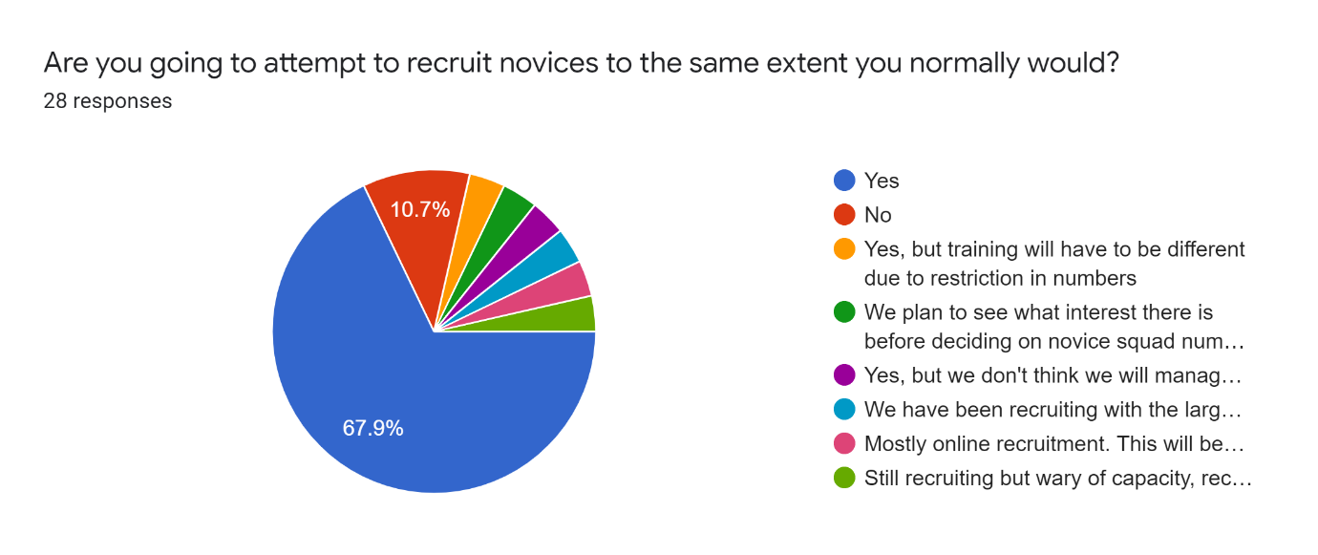
Comments:
Mostly online recruitment. This will be very different this year.
We plan to see what interest there is before deciding on novice squad numbers, but are opening the club to novices this year. Novices will initially be trained in small boats, giving us more flexibility in terms of numbers.
Still recruiting but wary of capacity, recruiting in different ways and have changes to novice programme planned
We have been recruiting with the large caveat that they may not get on the water this term.
Yes, but training will have to be different due to restriction in numbers
Access to sufficient resources to train novices in small boats? (ie tub pair, tub single, land tub)
50% yes, 25% no.
Comments:
Not enough to complete all novice training in small boats
We only have 1 tub. Will be moving novices into 8s pretty early
A few, but more limited in that only our boatman is allowed to take them out.
We'll be attempting to train novices in regular sculls, as is commonplace at many clubs nationwide. Novices will be coached 1 on 1 initially with ample throw bags etc.
LCCBC is partnering with another club to access their equipment: LCCBC has no fours, tubs or training sculls.
Entering Novice competitions:
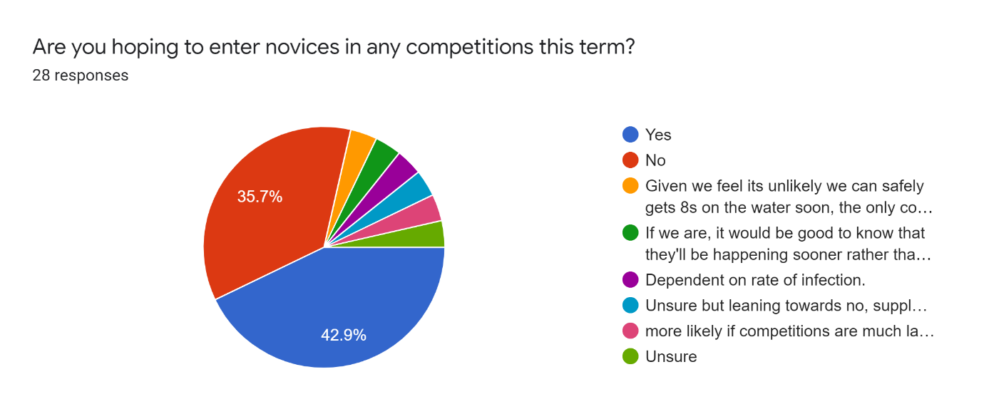
Comments:
If we are, it would be good to know that they'll be happening sooner rather than later so that we can plan ahead.
Unsure but leaning towards no, supplemented with internal club competitins
Dependent on rate of infection.
more likely if competitions are much later in term
Given we feel its unlikely we can safely gets 8s on the water soon, the only competition we'd plan to enter would be QErgs

Qu: Is your college restricting access to BH/Ergs?
For now, no erg access. When cleaning resumes soon, limited access to ergs and allowed upstairs in the BH again.
Yes. Clare Hall Gym is closed. College is probably not very happy with us exercising at the boathouse then
Yes. To comply with social distancing and government guidelines at all times.
Used to have 8 ergs in the boathouse. Now we only have 4.
Yes, only in small groups
One erg per erg room, with some ergs in the boat bays outside- other land training will be incorporated
The number of ergs we can use in the gym is down from 8 to 3
Yes, we will have to use the ergs outdoors, so are limited to days when it's not raining!
No access to ergs. Shared boathouse which is out of our control/ don't know yet.
Erg rooms and changing rooms closed, ergs available for use in boat bay
Yes; we will have access to half our fleet of ergs, in a room that we need to book that has restricted availability. The remaining ergs will be locked away and not available for members to borrow. I expect all access to be cut off in the case of any further COVID restrictions.
yes, we have no access
We're able to have 6 members on ergs and 3 on weights at any one time.
Reduced number of ergs, people in boathouse, recording who is in the boathouse, and closure of some areas
Yes - we are still able to use the ergs but with significant restrictions, rules, cleaning and tracking in place
No
College initially allowed limited use of the gym (~50% regular capacity) + some other changes to normal use (one way system, ventilation etc). College has recently entirely banned use of indoor gyms so the BH gym is currently closed, but we are working to re-open soon if poss.
Yes, less ergs are in use
Yes. Rule of six. All sessions must be preapproved. However erg volume is similar.
Similar booking of the erg room as last year, but we can only have a maximum of 6 people in the erg room (including coaches if coached erg)
Our erg room is limited to 4 at a time (as apposed to usually 8)
Only 6 people allowed upstairs in BH at one point, only 6 ergs which are spread out and bookable via a spreadsheet
Erging is allowed, but only in groups of 4 and under pretty strict conditions
Yes, only 4 people to use erg room at a time.
Only 4 people allowed in our gym at any one time
Gone from 16 down to 5 at one time. Only two slots per day, limited to evenings. Shared boat house means is likely only one erg session a week per crew.
Restricted numbers and hours during the day
Changing rooms not allowed, Ergs have been moves so are outside so don't have restrictions due to rule of 6 but are restricted due to weather.

Intentions for increasing land training and practicalities to do so
Without sufficient erg access, we expect to reduce land training on the whole but try to have more circuits sessions.
Yes. We do an online circuit twice a week
Same number per week as usual but more varied, to include zoom circuits and maybe self-led runs/cycle.
We intent to make use of zoom circuits to maintain fitness.
Ergs & Circuits, but mainly small boats
Outdoor training on college grounds in distanced groups, more cycling/running/etc encouraged- people can choose to not erg if they don't feel safe, but we will be setting ergs
Possibly depending on the restrictions throughout the term. We will provide all of those assuming that we are allowed to. If no gym access then we will rely on group runs/cycles and virtual circuits.
No. If anything I expect that we'll reduce our land training because we have less access to ergs. We have no access to a gym now that our college gym is shut.
Yes- land training only for novices (circuits/ running etc as no erg access). Increased cross training for seniors. Outdoor space available at college but no indoor gym facilities.
Circuits, runs and some ergs
We plan to increase circuit training opportunities, and to offer a 'fitness membership' for people who just want to join land training. I don't think that it will be possible to increase erg sessions, and our gym will be closed; circuits will be body weight and cardio focused, and outdoors (so weather dependent) or online.
circuits, running, cycling. Ergs hopefully at some point...
We will be diversifying the land training programme.
Hopefully, with ergs, gym, circuits, maybe a running club
Ergs, S&C room. Not intending to hugely increase land training
Same level as previous years, although we are splitting sessions up so there are max 6 people training on the ergs at once.
Absolutely! We have ergs which can be used outside if not raining and we are intending to run circuits and group land ut2 sessions (runs and cycles). We are also looking to use the gym if allowed to re-open.
We have hard courts available for circuits
Yes. S+C in boathouse bays for one session (group of 5 per side, rotating weekly). Have ergs and college gym. Encourage college gym sessions.
Yes, certainly increase ergs and tech ergs, and we will try and do circuits - we have discussed running zoom circuits where we can circuit together safely in our rooms
We have access to all of these but they need clearing through college first due to the 6 person rule
No, we will have less access to the college gym (don't have gym in boathouse) so fewer weights sessions, we'll be doing virtual circuits instead
Ergs, possibly circuits (we do not have access to a gym)
Land training will be limited due to practicalities with respect to the 6 person rule.
As mentioned, we will only have 4 people in the gym at once for weights and erg sessions. Planning to run circuit sessions in groups of 12 outside on the grass area of our boathouse.
Circuits, running. Unsure on how many can have for one class.
no
Yes, All novice training will be land based. We now have access to 8 ergs in college which, weather providing we can use. Our socially distanced circuits sessions were not approved by college so are having to be held via zoom.

Other comments:

Return to rowing
It all depends on college. As it looks like we will not be able to return to team rowing for quite a while.
We want to make returning to rowing safe and friendly and avoid injuries this term as people have not rowed for many months. We want to avoid putting pressure on seniors and novices by not having races and to allow for greater flexibility e.g. for those who need to self-isolate.
Our plans will be reassessed every two weeks- rowers are aware that situations may change. Full off-water training for coxes has also been planned should the situation arise.
Will there be plans to implement (e.g) a 1 or 2 boat rule immediately to moderate traffic and prevent public concern about perceived distancing?
We will offer novices the chance to join land training this term and to novice on the water in Lent term.
Our safety plan was a 2-month negotiation between 5 college bursars (the clubs that share our boathouse). Each college has agreed to the same safety plan for boathouse use and outings. Installed hand sanitizer units at the BH and marked out landing stages explicitly.
We rely on Peterhouse for access to boats, so returning to rowing will be difficult for us.
Phased approach, starting in IVs then moving up to VIIIs once we know we can do everything in a covid-secure way.

Land training
Same level of land training as previous, just with fewer people doing an erg/weights session such that we can maintain social distancing. We have a gym booking system to manage this which can also be used for track&trace purposes.
Doing ergs outside when possible; purchased portable LED flood lights.
We hope that we'll be able to continue outdoor circuit training even in the case of further COVID restrictions.
No college gym or indoor space available.
(Clare Hall) Happy to share practicalities of online circuits with people that are interested. It is a great way of including novices virtually and also provide a sense of community throughout college (our workouts are open to all college members).

Water training
Sculling looks like the preferred option for most of the senior team.
The college boat clubs being allowed / continuing to be allowed to row is going to rely on all of us following the Covid-19 precautions -- if there are massive outbreaks at boathouses then it will take no time at all for all rowing to be banned.
We do not have any access to anything other than 8s
CUCBC's advice on beginner rowing wearing masks has been very helpful, thank you!
We're not yet sure how we might be able to run organised water sessions - we will likely not be able to get out on the water for the first half of term, if at all (novices will almost certainly not be able to get out)

Racing
Unsure if the provision of novice racing will make it harder to recruit novices for those clubs who don't have sufficient tub access to get their boats on the water, with different approaches/facilities available to each club being highlighted by the extent to which we will be able to get back on the water.
Cancelled Emma Sprints - won't be taking place for either novices or seniors. As things stand, we do not consider Fairbairns to be sensible from a safety point of view - we have been advised not to enter.
Hoping to enter novices in races too. Otherwise we will lose them as there is nothing for them to work towards. We may arrange a semi-virtual erg event between our boathouse.
We are planning as if they will go ahead, but we are very aware that they probably will not go ahead for some time on the Cam
We will run an erg competition within the clubs that share our boathouse if no novice racing goes ahead.
Personally I would prefer if racing was postponed/ cancelled for this term: it seems unlikely seeing as restrictions are being reintroduced gradually, and having a bit of certainty would be appreciated at a time where everything seems up in the air
In the interest of fairness between colleges we do not support novice races this term.
We are keen to do races because racing is fun, and because rowing can otherwise become a relentless stream of early mornings, cold weather, hard fitness, and coaches shouting at you.
Stay tuned for virtual QErgs...
We will not be running CNR (Clare Novices' Regatta)
Really cannot imagine that we will have a novice crew ready for a Michaelmas rowing competition right now.

Support
It would be helpful for there to be some centrally-issued direction to guidance on health and safety for sculling; I can see a risk in clubs turning to small boats without coaches necessarily being experienced scullers or sculling coaches. (LCCBC is running an intensive learn to coach intro)

