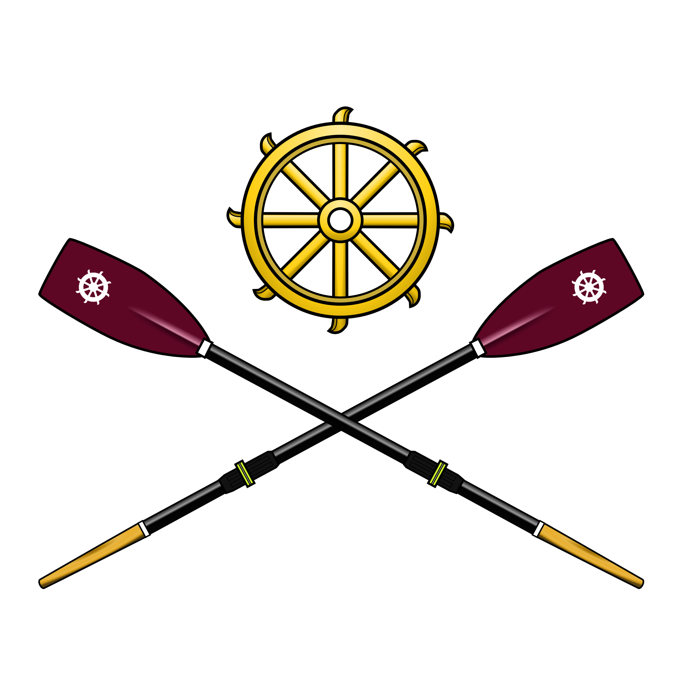
Part-time Coaching Vacancy at St Catharine’s College Boat Club
Cambridge

St Catharine’s College Boat Club is looking to appoint a coach for its Women’s squad for Easter Term, starting April 2018.
Founded in 1833, the club is ambitious and possesses a rich rowing history. With its own facilities, a modern fleet and driven young athletes, it aims to compete at both college and national events.
Role and responsibilities:
- Helping the women’s captains design, develop and implement a training programme for the squad to ensure a coherent approach across all boats.
- Leading at least 5 water sessions per week, delivering quality coaching for the first VIII, and also leading sessions for the lower boats. We are looking to be competitive in May bumps, but also to build the strength across the women’s side.
- Working closely with the volunteer coaches to ensure consistent technical standards throughout the squad.
- Offering support to all crew captains and volunteer coaches on training plans.
Requirements:
- Evidence of coaching experience with a proven track record.
- Ability to develop a targeted training programme for an ambitious boat club.
- Develop a squad structure by encouraging and supporting volunteer coaching by the athletes for the lower boats.
- British rowing coaching qualification (level 2 or higher) is desirable but not required.
What we offer:
- Newly renovated boathouse, erg room and gym.
- Modern fleet of eights and smaller boats.
- Driven and enthusiastic athletes.
- 40+ active club members incl. 3 competing crews.
Remittance will be dependent on experience held and hours negotiated, but will be competitive and on a session-by-session basis.
Potential applicants should forward their CV, along with a cover letter, by e-mail to the Club Captain, Stuart Knowles (sfk28@cam.ac.uk). Questions are welcome. Selection will be made based on an informal interview and trial outing, with a view to starting as soon as possible.

