
Fairbairn Cup Races 2017
Coxes’ Notes
Fairbairns can be a fairly tricky course to steer, particularly as there are corners you are not likely to have tackled at race pace before. It is recommended that you talk to senior coxes at your club for advice on your race plan and cornering.
Unfortunately, over the years, we have had to introduce some tough rules and regulations to ensure the smooth and safe running of the races. The following is some information and advice that you may find useful and hopefully will allow you to avoid incurring penalties. Before racing, you should consult the Rules and Regulations (available at http://jcbc.jesus.cam.ac.uk/Fairbairns/rules.php).

Before Boating
Before your crew can be allowed to race, under CUCBC and ARA safety regulations, you must check that:
- You are wearing a lifejacket.
- Your boat has a bow ball.
- Heel restraints are properly attached at all seats.
You will need to collect your race numbers from Jesus College Boathouse at least 45 minutes before your division’s published start time. Three race numbers will be issued per crew – one for your back, one for bow’s racing kit and another for bow’s pre-race outer kit. Race numbers on yourself and bow must be visible to the Marshals at all times.
Your crew will have to warm up on land, either on ergometers or running/jogging as there is not enough room on the river for every crew to go for a warm-up paddle. If any crew does attempt to warm up on the water, they will race for time only or be disqualified (under Rule 4-1a).
Make sure your crew has enough outer clothing to stay warm whilst waiting in the Start Marshalling Area and a plastic bag to keep it dry during the race.
Novice crews must be accompanied by a bank party at all times, but the maximum size for any bank party is four.

Start Marshalling
The first 10 crews must be within the Start Marshalling Area 30 minutes before the division’s published start time, and all other crews 20 minutes before the start time. Latecomers will receive a 5 second time penalty if they cause delay to the start of the division. Make sure you boat on time!
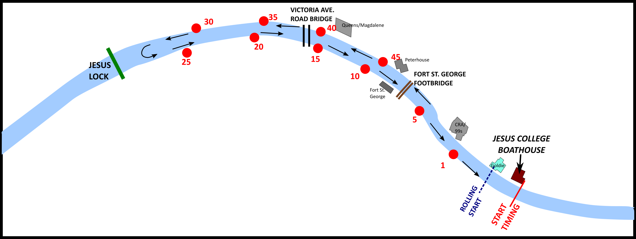

Crews will assemble, pulled in to the bank, upstream of Goldie Boathouse with the first half of the division pointing downstream on the Fort St. George side and the second half pointing upstream on the boathouse side. Once the first 10 crews have started racing, the remaining crews on the Fort St. George side will move up to the start, allowing the second half of the division to row to Jesus Lock and spin.
Crews will be allowed to get out of their boats provided that they are in position, their boat is not causing obstruction to the circulation pattern and the location of their boat allows them to do so. Crews must ensure that they remain within reach of their boats and must get back in when instructed to do so by a marshal.
Please help to maintain the flow of the circulation pattern by moving quickly and without stopping once you see the crews ahead proceeding to the start – this will help us to ensure that the races run on time.

The Start
At the start, crews will be under the control of the Starter. You will be asked to move up to the start (outside Goldie Boathouse) and raise your hand. Signal to the Starter when you are straight and ready to go by lowering your hand. After a suitable gap (around 30 second intervals between crews), the starter will call “Attention, Go.” You will then perform a rolling start, a sprint start is not required or advised as this takes longer so holds up later crews and there is enough space to get to race pace before timing begins at the Jesus College Boathouse flagpole. Please start moving on the “Go” to minimise delays to other crews.

Overtaking
We try to minimise the need for crews to overtake on the course by altering the gap between starting crews. For safety, there is no overtaking before Bumps Men’s Top Finish (post just downstream of Chesterton Footbridge) – crews disobeying this rule will be disqualified (Rule 13.a). If you or your Captain believe that you may be in a position to overtake the crew in front before Men’s Top Finish with a 30 second gap, you may contact the Fairbairns Secretary at least 7 days before Race Day to request a larger gap.
If you have to overtake or find yourself being overtaken (after Men’s Top Finish), try to minimise disruption to the other crew. The slower crew should give way to the faster crew, steering out of their path. Any deliberate impedance of another crew will result in a penalty depending on the dangers resulting from your actions. You should only overtake when it is safe to do so! If you feel you have been impeded in any way, speak to a Finish Marshal as soon as possible so that your concerns can be recorded. In keeping with British Rowing regulations, there will be no time adjustments so please take a good look at the start order and look at how fast the crew ahead has been in other races. We will increase the time gap or change the start order depending on the disparity, please provide evidence (race times) to the Fairbairns Secretary at least 7 days before the race.

Crashing Out
This does happen from time to time, but try not to! If you do crash, you need to clear the river as quickly as possible – another crew could be very close behind you. Remind your crew that, in any event, they must remain responsive to your commands and stay with the boat should they end up in the water. Only once you are clear of the river will you be able to assess damage and tend to any injured persons, so clearing the river should be your first priority. If you decide to row on, only push off from the side if there are no crews behind you that may be impeded. If there are then let them pass and continue when it is safe to do so

Finish
A crew will be deemed to have finished racing when the bow ball crosses the finish line:
- Novice VIIIs: The railings on the Long Reach.
- Senior College and Invitational VIIIs: Little Bridge downstream of the Motorway Bridge.
- Senior College and Invitational IVs: Red Grind Post (upstream post opposite the Plough).
As you cross the finish line, you will hear a horn.
You must keep rowing as you cross the finish line – crews could be coming in very close behind you at race pace.
Keep rowing at light pressure until instructed to stop, spin and pull in by a finish marshal. You should urge your crew to put on any dry outer clothing as soon as possible even if they are warm from racing. They will cool down quickly and there can be a bit of a wait before you will be allowed to row home. If you believe a member of your crew is becoming too cold, contact a Finish Marshal immediately.

Rowing Home
You will only be permitted to return to your boathouse once the entire division has finished racing. Jesus College Boat Club crews will be allowed to return first in order to facilitate marshalling of later divisions.
It is important that, when instructed to do so, crews row steadily back to your boathouse so as not to delay the start of later divisions. You should obey normal navigation rules when rowing home.
Please note, your race time will not be available from the Finish Marshals; all results will be published online and at Jesus College Boathouse at the end of the day’s racing.

Race Marshals
All Marshals will be wearing yellow fluorescent bibs. They will note any complaints you may have and any penalties for causing obstruction during an overtake etc. Senior Umpires will be positioned along the course with radios, wearing red coats, and are in contact with the Fairbairns Secretary at Jesus College Boathouse. You must obey all instructions from Marshals and Umpires.

Medical Emergencies
A team of first aiders from St. John’s Ambulance will be in attendance throughout the races, stationed at Jesus College Boathouse between divisions but spread out along the course on bicycles during the divisions. Senior Umpires will be in radio contact with them, so get the help of a Marshal in the first instance should the need for medical assistance arise.
More information, including the Rules and Regulations can be found on the website at www.fairbairns.com. If you have any questions do not hesitate to get in touch.
Finally…Good luck and have fun!!
Charlotte Jackson
JCBC Fairbairns Secretary 2017
jcbc-fairbairns@jesus.cam.ac.uk

Coxing Fairbairn’s for newcomers

The Fairbairn Cup course is tricky to steer, even with the size of rudder generally found on the River Cam. Several of the corners are rarely taken at race pace, especially in the downstream direction, so careful coxing is required. Coxing can have a substantial impact on the race time, especially over the Senior VIIIs course, so make sure you get it right!
Make sure you have a race plan; although there are many landmarks to push off, the course is still very long and will take most crews over 15 minutes to complete (for Seniors). There is generally negligible stream on the Cam; wind may be more of a factor.
Coxes are highly recommended to cycle the course beforehand if new to Cambridge since the River
Cam has some substantial bends. Viewing Google Earth satellite photography is also a good idea.
Note that the river is narrow in many parts and thus overtaking can be difficult.
The following corners will be the main challenges. Only basic advice is given here – the rest is where your experience comes in!
Elizabeth Way (under the flyover marked "The Road Bridge" on the map)
This isn't a particularly difficult corner but some boats still crash here most years! It is very near the start (making a crash all the more embarrassing) so line up your boat correctly on the way in to take the tightest line under the bridge. You will probably not have reached race rhythm so make sure your strokeside rowers are ready.
Chesterton corner (under Chesterton Footbridge)
This is a tight corner but with careful steering is fine. Make sure you turn in early to get round (it will require maximum rudder) and do use your rowers to help you round.

Ditton Corner
Approach on the right‐hand side and turn in fairly late. This is a long and fairly tight corner, and can prove difficult if entered incorrectly.

Grassy Corner
This is probably the tightest corner on the course, and is rarely attempted in this direction at speed. Approach close to the left hand bank and do not turn in too early, since you will then have to take the rudder back off and this will send you straight towards the outside bank! Be prepared for the double apex and plan accordingly…

First Post Corner
Very similar to Ditton Corner.
Do have a look for some photographs of the river and corners as preparation – a list of Cambridge boat club websites can be found on www.cucbc.org – but there is no substitute for viewing (or coxing!) the corners in person before racing.

