RADEGUND MILE 2017 ENTRY FORM 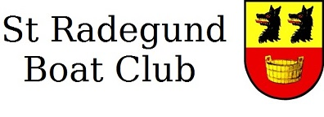
The St Radegund Boat Club would like to invite you to race in the Radegund Mile Head Race on Saturday 15th April 2017. The course runs upstream over one mile from outside the Plough to Two Tees boat shed.
Entries and payment will be received until midnight on 11th April.
To enter, please return a completed copy of this entry form to events@radbc.org.uk and use bank transfer to pay the race fee as detailed below. If a bank transfer is not possible, please contact the Race Secretary at events@radbc.org.uk. Boats may only race on the day upon receipt of payment.
Race costs are £7.00 per head. No charge for coxes.
- BACS details
  - Sort Code: 30 64 42
  - Account number: 69821368
  - Include Club and Boat Name(s) in the reference

Club/College Name
Contact Name
Email
Telephone
Crew No. or Boat Name | Affiliation |  | M / W | Category entered* | Masters Category/ Junior Age (if applicable) | Boat Type | Preferred Division  (10.30 or 11.45) | Predicted Time for 1 mile  (1.61 km)
*Available categories are listed below. Student crews please assign yourself to the most appropriate category. Note that prizes will only be awarded in categories with at least 3 entries.
- Junior
- Novice
- Intermediate (covers BR categories IM1, 2 and 3)
- Senior
- Masters

