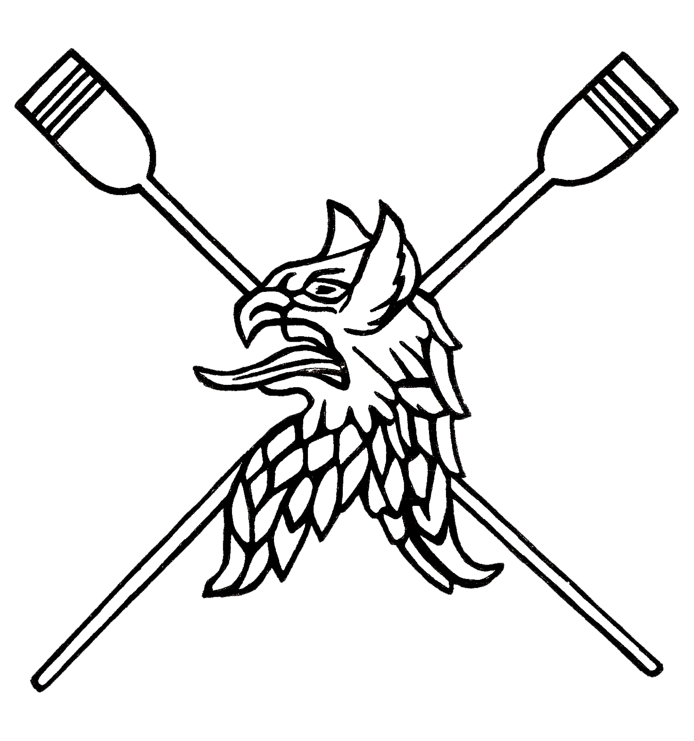
Newnham Short Course 2017
Marshalling Instructions

- The first digit of your race number corresponds to your division.
- Marshalling for division 1 will be at the lock and all the boats must be spun and pulled in by 11am.
- Marshalling for division 2, 3, 4 and 5 will be between Chesterton and the P&E on the meadow side.
- You must be marshalled by the time stated on the timetable.
- Coxes must be wearing a working lifejacket and know how to operate it. Marshalls will also be checking heel restraints and bow balls.
- Please ensure that the Cox and Bow person have all race numbers clearly visible to marshals.
- The last 2 digits of your race number correspond to your marshal position, with 1 being nearest Chesterton through to 20 being nearest the railway bridge.
- On the marshals’ instructions, boats will be pushed out and will row down to the Lock in reverse order.
- At the Lock they will spin on station ‘bumps style’ (remaining in order) and pulled into the bank
- Boats will be called to do a rolling start from about 3 Lengths from the start, with the timing starting as their bow crosses the start line, at the Motorway Bridge.
- Timing stops as the bow crosses the finish line, at the Railway Bridge.
- Crews MUST continue rowing after the finish line.
- Results will be posted on the website as soon as possible after the race.
Division | 1 | 2 | 3 | 4 | 5
Marshalling Time | 11:00 | 11:45 | 12:50 | 13:55 | 15:00
Race Start | 11:15 | 12:20 | 13:25 | 14:30 | 15:35

