BUCS Indoor Rowing Entry Form Host: University of Cambridge

Entry From (your University):

College (Cambridge only):
E-mail Contact for Entry:

INDIVIDUAL ENTRIES

Competitor Name (BLOCK CAPITALS) | Event (snr M/W, Lwt M W, Beg M/W  RowAbility)

Please list teams overleaf. Please note that the entry fee of £4 is per person and not per event. As such, an eligible individual may be entered in both the Senior Men’s Individual and Senior Men’s Team event for the cost of the £4 entry fee.

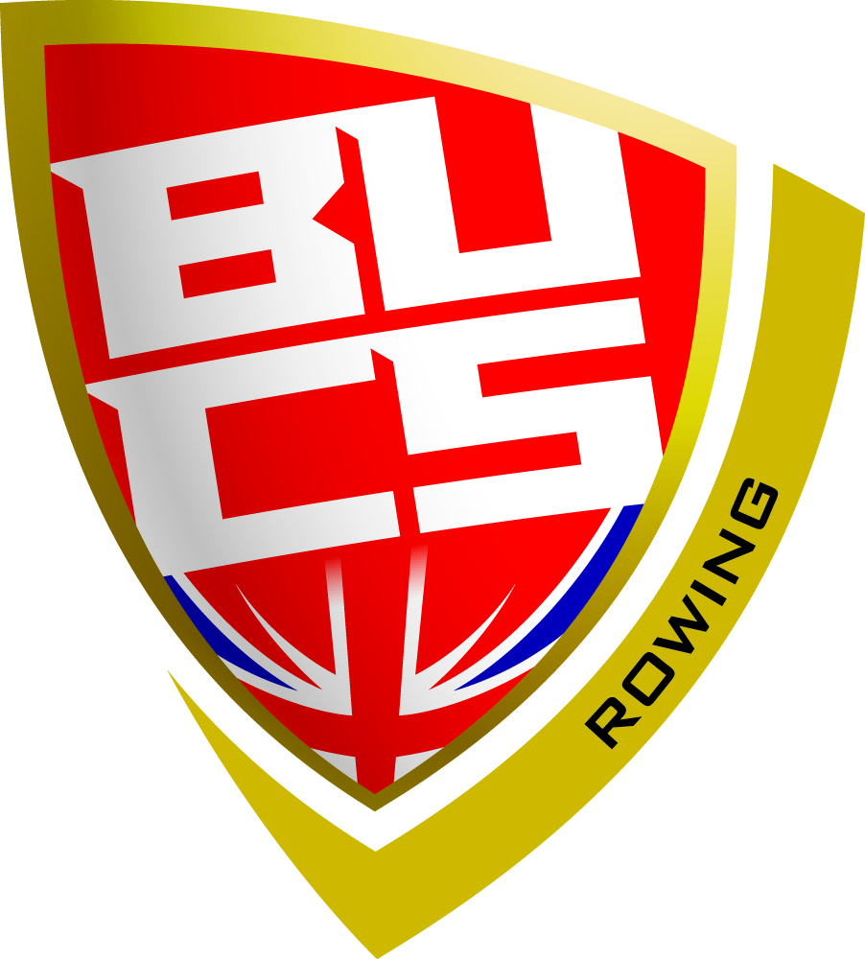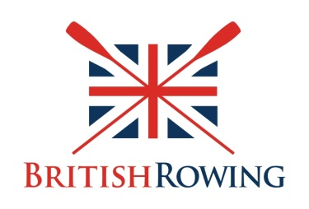

TEAM EVENT ENTRIES
Team A : (Senior Men / Women)
1.
2.
3.
4.

Team B : (Senior Men / Women)
1.
2.
3.
4.

Team D : (Senior Men / Women)
1.
2.
3.
4.

Team E: (Senior Men / Women)
1.
2.
3.
4.

Team C : (Senior Men / Women)
1.
2.
3.
4.

Please note that your AU/SU President (or equivalent) must sign this form as approval of your entry. The signing of this form by the AU/SU President is confirmation of his/her part that all entrants listed above comply with BUCS eligibility requirements, and all entrants confirm they accept the conditions of entry to this event.
Boat Club President/Captain (PRINT NAME):
Boat Club President/Captain (PLEASE SIGN): DATE:
AU President Name/Sports Officer (PRINT NAME):
AU President/Sports Officer (PLEASE SIGN): DATE:

