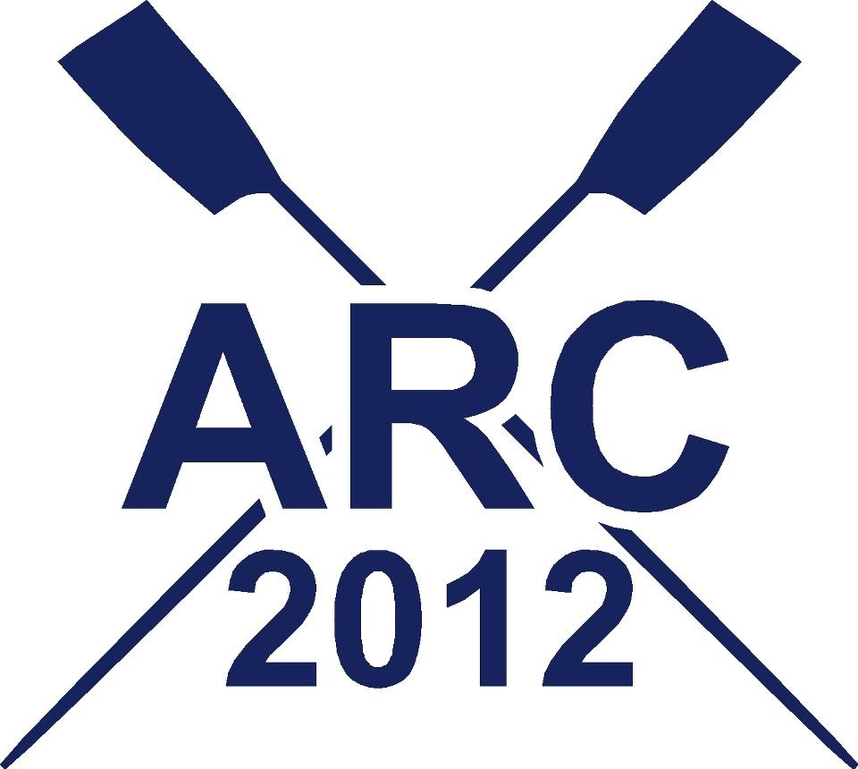
ALTON WATER AUTUMN HEAD

Held under the Rules of British Rowing and organised by the Alton Rowing Club will be held at Alton Water, Holbrook Road, Stutton, Suffolk, IP9 2RY over a distance of 3,200 meters on

Saturday 23rd November 2013
Please see our website www.altonrowingclub.com for further details

Entries will be invited for Open, Women’s and Mixed races in Sculls, Pairs, Fours & Eights in both coxed and coxless to row in two divisions at 11:00 am and 2:00 pm

Race Organiser: Jimmy Jewell e-mail taywelljim@uku.co.uk

11:00 am Division 1
Open, Novice, Junior and Masters (BR Handicap System): 1x, 2x, 2- & 8+
Women’s Open, Novice, Junior and Masters (BR Handicap System): 4x, 4-, 4+ & 4x+
Mixed: 2x & 2-
2:00 pm Division 2
Women’s Open, Novice, Junior and Masters (BR Handicap System): 1x, 2x, 2- & 8+
Open, Novice, Junior and Masters (BR Handicap System ): 4x, 4-, 4+ & 4x+
Mixed: 4x, 4-, 4+ & 4x+

Regular updates will be sent via e-mail to your club. If you require these updates to be sent to someone else in your club please forward an e-mail address to the Race Organiser.
Please use the BR Online entry form and send with the entry fee of £9 per racing seat to the Race Organiser: Jimmy Jewell, 11 Whatley Close, Elmswell, IP30 9GJ. Tel: 07811 504630

WINNERS Pennants will be awarded to the fastest crew in each category that has a minimum of two boats competing.

Entries close on Monday 18th November 2013 at 5:00 pm and the race order will be available on our website www.altonrowingclub.com by Wednesday 20th November 2013.

