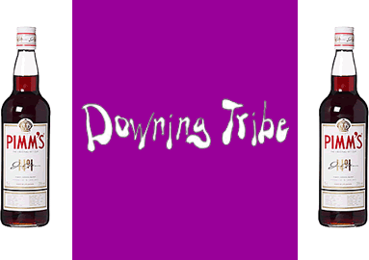
Terms & Conditions
These terms and conditions serve as agreement made on today's date between THE GUEST of Cambridge University, Cambridge and THE ORGANISERS (The Downing Tribe of Downing College Boat Club, Cambridge, CB2 1DQ)
- Group Ordering Application for groups of people may be submitted by email. Group booking should be greater than ten persons. The organisers of the event will contact all people placing group bookings. The organisers may not be able to locate as many tickets as a group requests but will endeavour to do so if possible.
- Discounts There will be strictly no discounts for any groups or individuals.
- Late Payment Receipt of full payment for the requested tickets is due to The organisers immediately upon the sending of the application form. If payment is not received within five working days from the sending of the application form, the application for tickets will be rejected and if a cheque arrives at a later date it will be destroyed.
- Acceptance of Applications This event has a maximum capacity of 1,000 persons. It is likely that the number of applications will well exceed this number. The organisers will therefore have to reject applications and reserve the right to reject any application for any reason. The guest will be notified by email regarding the status of their application on or before 2 June 2013.
- Sending of Tickets All tickets will be sent on or before 9 June 2013. They will be addressed to the name and college provided by the guest via email. A confirmation of your application will be sent by email. If you have not received ticket by 9 June 2013 please email tribalchieftain@gmail.com immediately.
- Door Policy and Security The guest must present a valid ticket to gain entry to the event. The tickets contain a number of counterfeiting measures. The organisers reserve the right to refuse admission for whatever reason, even if the request can produce a valid ticket. Alcohol and any illegal substances not allowed to be brought into the event and any person that appears to be inebriated will be refused access to the event or ejected. As in the past, a professional security company will be providing security.
- Complaints Complaints can be made within 10 days of the event in writing to: Pedro Vila de Mucha, Downing Tribe, Downing College, Cambridge, CB2 1DQ tribalchieftain@gmail.com
- Refunds There will be strictly no refunds for any reason other than the cancellation of the event.
- Liability The organisers shall not in any circumstances accept liability for any damages, compensation, losses or other liabilities direct or consequential.
- Provision of the event While event times, entertainments and location have been indicated to the guest in good faith at the time of enquiry, the event offered is subject to the actual availability at the time of ticket application processing and the organisers accept no responsibility in being unable to supply the event or any part of it.
The application for tickets by the guest is taken as acceptance of these terms and conditions.

