X-Press Head Race
Monday 18th June 2012
One division at 7pm

Categories: All categories welcome
Course: 2,600m from the Motorway Bridge to Green Dragon Bridge
Crews must be past Green Dragon Bridge by 6.40pm

Cost: £6 per seat (coxes free)
Cheques: Payable to “X-Press Boat Club”, by post or on the night
Numbers: available from City Boat House after 5pm
Late Entries: between 5 & 6pm at City BC, if spaces available
Bar: City BC bar open for refreshments after the race
Entries online: http://x-press.aci-net.co.uk/register.cgi?event=1
Sue Sutcliffe
22 The Lane
Hauxton
CB22 5HP
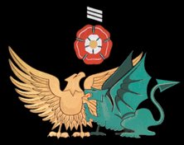
01223 874 008
07762 375 097
xpresshead@xpressbc.org.uk

