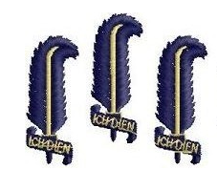
Oriel Regatta 2012

Dear Boat Club Captain,

On Friday and Saturday 8th-9th June (7th Week) Oriel College Boat Club is pleased to again host the annual Oriel Regatta, which for the first time this year is inviting colleges from Cambridge to compete. Racing will be from 11am until 6pm. The racing will be side by side over a buoyed course run upstream from Timm’s to just past the end of the boathouses on the Christ Church Island.

Prizes of engraved pewter hip flasks will be awarded to the winners of each category below:

- M 1x, W 1x
- W2x; M2x
- W2-, M2-
- W4x, M4x and mixed 4x (min 2 women)
- W4x +, M4x + and mixed 4x + (min 2 women)
- W4+, M4+ and mixed 4+ (min 2 women)
- Novice 8+ (college 3rd crews and below only)
- Mixed 8+
- W8+, M8+
- Exhibition race TBC

We would like to encourage entries of inter-collegiate racing so please feel free to enter composite crews. All categories are dependent on there being a minimum of four entries. Please ensure all single scullers, doubles and pairs have done a capsize drill.

Entry costs:
1x: £6 per head
2x/-: £12 per crew
4x/-: £28 per crew
8+: £56, if we get more than 20 entries the cost will decrease to £48 per crew

So come and escape the stress of exams and enjoy an afternoon of racing in the sun. For information please feel free to contact me at the address below.

Entries are open NOW, to enter please complete the entry form on the OURC website. Please find enclosed a paper copy of entry forms to fill in as well, and send it along with a cheque to Oriel College Boat Club to Siobhan Abraham (regatta secretary) at Oriel. The closing date for entries is midday on 5th June (Tuesday of 7th week).

Please note that the last chance to scrap is by 6pm on Wednesday 6th. This gives us time to potentially reorganise the draw and inform crews that may then have a bye. Any crew that has not scrapped before this deadline will be charged their entry fee, if they are able to race or not I’m afraid!

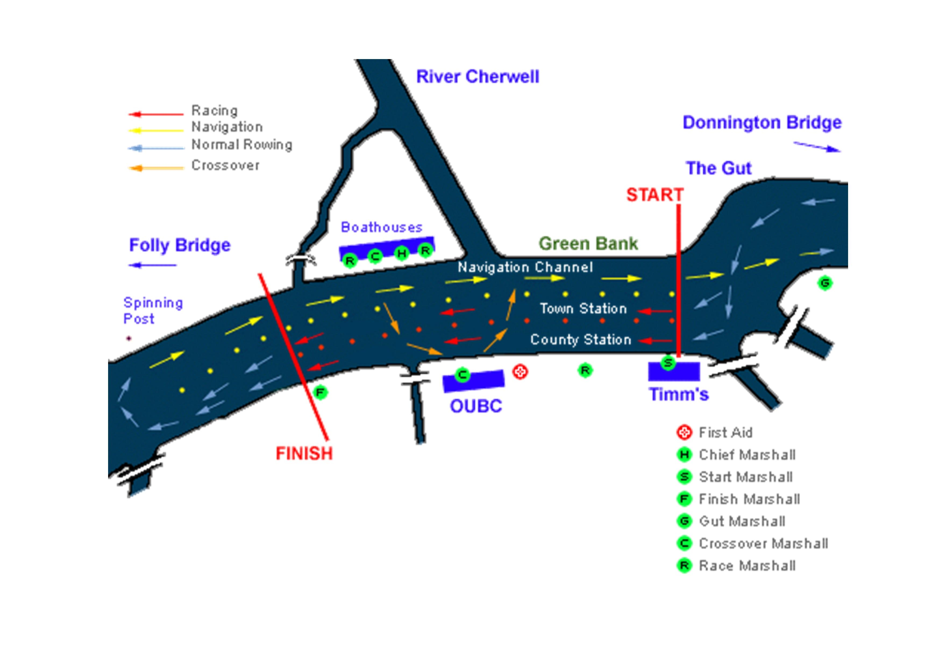
The race course is:

Yours,

Siobhan Abraham
Oriel Regatta Secretary

siobhan.abraham@oriel.ox.ac.uk
07917869041

Oriel College Boat Club, Oriel College, Oxford OX1 4EW

