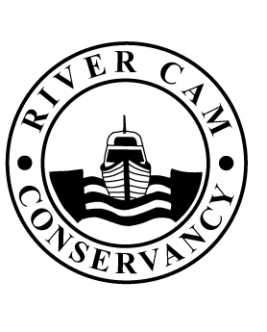

CONSERVATORS OF THE RIVER CAM
Navigation authority for the River Cam, between Cambridge and Bottisham Lock

12 April 2012

Dear Water Safety Advisor

As you may be aware, there was a serious incident on the Cam navigation on 8 March involving a motor cruiser and junior sculler adjacent to the CRA Boathouse. The skipper of a motor cruiser, which was travelling upstream, managed to negotiate two Virus sculls but he did not see the training line attached to the third. The cruiser went over the rope and it became entrained around the propeller. In a matter of seconds, the scull was taken in tow and dragged under the water, causing a capsize. The junior acted correctly by remaining with the scull however both were drawn towards the stern of the motorcruiser. Fortuitously, the engine was shut down quickly and there were no serious injuries. The alternative outcome could have been horrific.

In the course of our investigations it has become apparent that training lines are sometimes used when coaching novices until they are sufficient competent and confident to master their craft unassisted.

The Conservators have reviewed this incident with the parties involved. Some safety recommendations are set out below.

- if training lines are to be used, they should be made of brightly coloured floating rope (i.e. yellow) with additional red plastic floats attached at regular spacing intervals, suggested 1 – 1.5 m apart;
- a responsible banksman should be present at the upstream and downstream limits of the training area to keep a lookout and to warn novices of approaching river traffic (a whistle may be useful since the voice can often be lost in windy conditions or against background road traffic noise);
- training activity should to be suspended and craft should draw into the banks to allow other river traffic free passage;
- craft should keep to the correct navigation lane as best as is practicable and not be allowed to drift towards the opposite bank, contra the normal rules of navigation.

Clubs are reminded that British Rowing requires risk assessments to be completed for all of their activities. If your Club uses training lines in its coaching programme, the control measures set out above may need to be added to a revised risk assessment.

Pip Noon
River Manager

