EASTERN REGION CONFERENCE 2011
Coaching Technique Juniors Steering
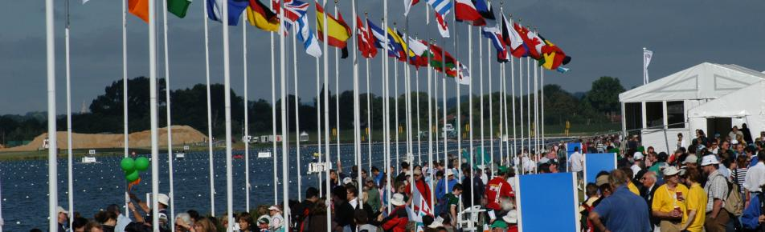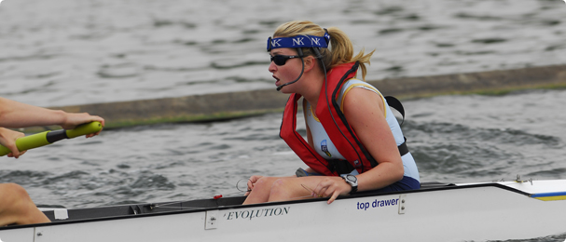

Presentations

Technique: from theory to results: Robin Williams,
Former lightweight international, CUBC chief coach and coach to the British Olympic lightweight squad

Junior Development: John Layng, British Rowing Junior Team Manager
and
“Improving Coxing and Steering in Your Club”

“Preparing to Race”

Sunday, 4th December 2011
Venue: The Recital Hall, King’s School Ely, The Gallery, Ely, Cambs. CB7 4DB
Time: 09.30 to 16:00
The conference will close with the Regional AGM from 15.00 to 16.00 pm
Cost is £15.00 including refreshments and Sunday Lunch
This conference is for all Club Chairmen, Captains, Treasurers, Coaches and other Club Officials who have an interest in any of the selected topics.
You will have the opportunity to meet with British Rowing staff; coaches and members of the Eastern Region Rowing Council

Numbers are limited so please apply before Monday, 21st November 2011

To reserve a place or for further information please contact your
Regional development officer:
sharon.noble-layng@britishrowing.org

Eastern Region Rowing Council Conference, 4th Dec 2011

Venue: King’s School Ely,

Timetable:

Timings | Speaker | Topic
Arrival 09:30 – 09:45 | Tea & Coffee
09:45 – 9.55 | Brian Hawden | Welcome, Notices,
10:00 – 11:00  11:00 to 12:00 | Steve Brown, Vicky Parry  David Wynne, Roger Croome | Improving Coxing and Steering in your club  Preparing to Race
10:00 to11:00  11:00 – 12:00 | David Wynne, Roger Croome  John Layng | Preparing to Race  GB Junior rowing
12:00 – 12:15 | Brian Hawden | Regional Presentations
12:15 – 12:30 | Move to Lunch
12:30 – 13:30 | Lunch
13:30 – 14:45 | Robin Williams | Coaching Technique
Break | Tea / Coffee for those staying for the AGM
15:00 – 16:00 |  | AGM
16:15 | Depart

EASTERN REGION CONFERENCE 2011

Delegate application form
Cost £15.00 to include refreshments and a Sunday Lunch
Group discounted rate for 4+ applications - £12 per head

Name | Position | Club | Any Special Dietary requirements

Please forward individual or club applications to sharon.noble-layng@britishrowing.org

You can pay either cash or cheque on the day

