Manifesto for CUBC Honorary Secretary - Karla Borland (Caius)

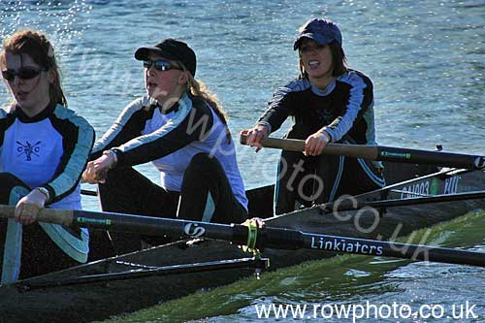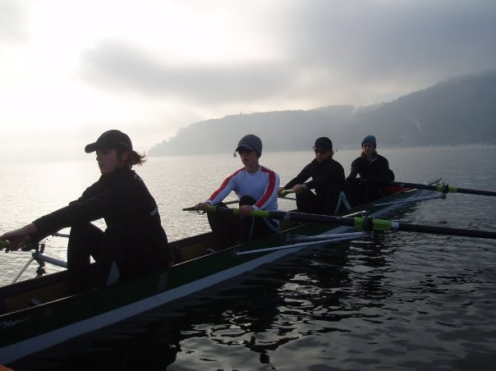

Proposed by Tom Edwards (Caius), Seconded by Marco Espin (Caius)

About me
I’m a 3rd year vet student about to start the clinical part of my degree. I’m known for my keenness for all things rowing, my bad jokes, dessert-making skills and Irish accent.

Rowing Experience
I sculled for Bann Rowing Club while at school, competing in a variety of local and national events including the Irish Championships. While at Bann RC I rowed and raced in everything from a single to a four to an octuple. At Caius I’ve rowed, coached or coxed for a variety of crews in countless races and all sets of bumps since I arrived.

Committee experience
I was secretary of Caius Boat Club last year which involved everything from race entries and minutes to kit design and orders. This year I’ve been Overall Captain of Caius Boat Club and Caius Athletics Representative. While Captain this year I organised our first foreign training camp for 28 rowers and 3 coaches to Annecy in France. I’ve also set up a steering committee for the club, secured the renewal of our sponsorship contract, set up a small fund for university rowers and am in the process of organising a May Bumps event for benefactors and students. While doing all this I’ve coxed and rowed and ran a marathon.

Why should you vote for me?
I’m organised, friendly, enthusiastic and focused. I want to use the skills I’ve gained as secretary and Captain of Caius to contribute to college rowing as a whole. CUCBC and CUBC rely on efficient committee members to allow the students involved to concentrate on rowing and to compete successfully and safely. I believe I would be an asset to both CUBC and CUCBC in the role as honorary secretary.

