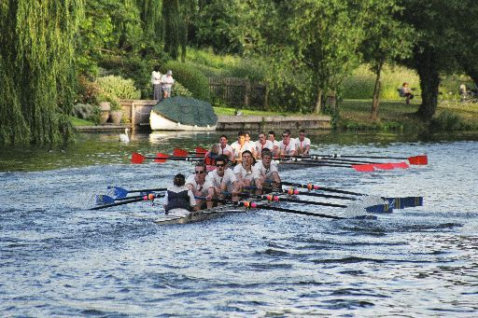
Cambridge Nines’ Regatta

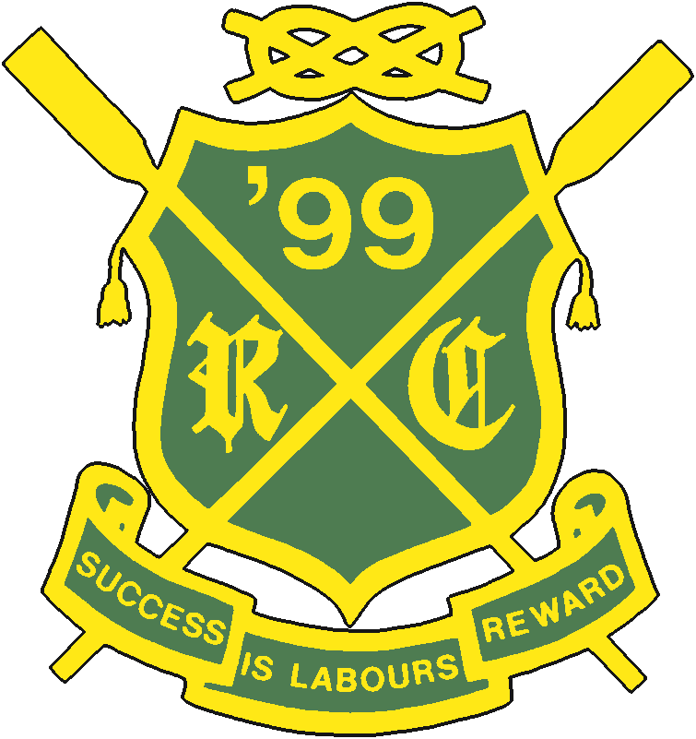
Sunday 25th May 2008

- 1000M (Approx.) Race ~ Ditton Corner To Morley’s Halt
- Entry £40 per Crew (enter three crews get a fourth free)
- Plate Competition ~ All crews get at least two races
- Divisions arranged to minimise time between races
- Glass tankards to all event winners
- Barrel of Beer to winners of Mixed Eights!

Race Events ~ Men’s First Division Eights
Women’s First Division Eights
Men’s Second Division Eights
Women’s Second Division Eights
Men’s Lower Division Eights
Women’s Lower Division Eights
Mixed Eights (4 male & 4 Female)
Town Eights (lower divisions)

Entries to: events@nines.rowing.org.uk

