REVIEW OF THE CONSERVATORS’ MOORING POLICY, FEBRUARY 2008

1. INTRODUCTION

1.1 The purpose of this review
For the purpose of maintaining navigation, the Conservators have for several years applied a policy to restrict mooring along certain areas of the statutory navigation between Bishop’s Mill and Bottisham Lock. The Conservators’ Mooring Policy which was approved in 2000, and Amendments (adopted in 2004), are attached (Appendix 1). As with any Policy, it is appropriate that its effectiveness in managing navigation should be reviewed. There are two areas where boats habitually moor which could be creating a conflict with other navigators, specifically:

1) Riverside Walkway, between Quayside and Jesus Green; and
2) Riverside retaining wall, between Elizabeth Way Road Bridge and Stourbridge Common.

In addition, a third area of the Conservators’ Mooring Policy was due for review on 1st October 2007, namely:

3) Victoria Bridge to Eights Marina (due for review).

Finally, it may be that there are no navigational grounds for continuing to prohibit mooring along Jesus Green Frontage upstream of Jesus Lock. Thus the fourth area for review in this document is:

4) Jesus Green Frontage.

This review document looks at these zones in detail, offering possible modifications to the current Policy for the benefit of navigation.

At the Conservators’ meeting on the 20th September 2007 it was agreed that geographical terms used in the 2004 versions of the Mooring Policy would be updated for the benefit of river users. For example, the old gasworks, the disused tennis courts and old Philip’s boathouse are no longer obvious or visible landmarks owing to the recent housing developments which have taken place on both banks of the river. It was agreed that these locations would be identified with their new street names.

1.2 Navigating the River Cam
The River Cam attracts a mixture of craft of varying dimensions using different methods of propulsion. The Statutory Navigation can be split into two main reaches according to the characteristic usage by vessels:

- Middle River, King’s Mill Weir to Jesus Lock – mostly punts, some canoes and kayaks, occasional motorised vessels when permitted by appointment from 1st October to 31st March inclusive and a handful of residential boats at Jubilee Gardens; and,
- Lower River, Jesus Lock to Bottisham Lock – many rowing vessels, day and residential motorised craft (cruisers, narrowboats and barges), houseboats, commercial hire craft, sailing boats and canoes.

These vessels have different requirements for safe navigation and mooring. Nationally, fifteen metres has become an accepted navigation fairway width if the geometry of a river or canal, including available depth of water, allows it. With such a fairway, most vessels can pass and overtake each other safely without risk of collision. The River Cam is unusual as compared to other navigations in that a large number of rowing vessels use the Lower River. Feedback from the first draft of the Conservators’ Mooring Policy in 1997 resulted in the conclusion that 20 metres provided an adequate navigation fairway width. This width would enable two rowing eights to pass each other without having to ‘ship oars’. However, curved reaches of the navigation might require a greater width. There are certain stretches, for example, Riverside, where a navigation fairway in excess of 20 metres is required to ensure full visibility for vessels rounding the bends.

The common definition of ‘mooring’ is contained in Appendix 2. The statutory basis for the Conservators regulation of mooring is set out in Appendix 3. The statutory role of Control Officer is now undertaken by the River Manager. The Conservators’ River Bailiff enforces the Conservators’ Mooring Policy by serving time-limited notices on the vessel owners. Any vessels deemed to be abandoned are reclaimed to the Conservators’ depot at Clayhithe under the terms of Byelaw 11.

Cambridge City Council has its own Mooring Policy, the significant features of which are: (i) there is no conflict with the Conservators’ Mooring Policy where mooring is permitted and prohibited; and (ii) it applies to riparian lands which are either owned or managed by the City Council (e.g. the Commons).
1.2 Timescale of this review
This document is to be circulated to a wide range of stakeholders for comment in February 2008 and it will be available for viewing on the Conservators’ website at www.camconservators.org.uk. Comments will be collated by the River Manager and the outcome of the public consultation will be circulated to the Conservators, with recommendations, in advance of their quarterly meeting on 10th April 2008.

Submissions must be made in writing and must be returned to the office address below by midday, Friday 14th March, 2008.

The River Manager
Conservators of the River Cam
Baits Bite Lock
Fen Road
Milton
Cambridge
CB24 6AF

Email: river.manager@camconservators.org.uk
2. MOORING ZONES UNDER REVIEW

2.1 Riverside Walkway (between Quayside and Jesus Green)

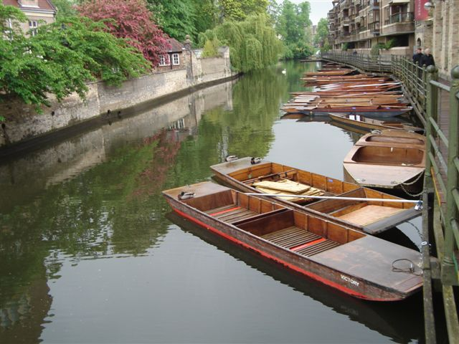

▲ View downstream from Quayside showing punts moored along
Riverside walkway

Location | Middle River, between Quayside and La Mimosa Restaurant (Jesus Green)
Length (approx.) | 160 metres
Structure | A suspended wooden walkway which carries the public footpath along the right (east) bank of the river. Wooden ‘barge-boards’ are affixed along the length of the walkway to prevent objects from becoming entrapped underneath the decking. Metal railings guard the public from accidental falls.
Navigation width | Fairly constant, being some 20 – 25 metres wide. The river bed profile drops off sharply; almost the entire width of the river is navigable. Where the retaining wall off Magdalene College bows out slightly, the channel width is reduced to approximately 14 metres.
Other navigation factors | Magdalene Bridge, some 50 metres upstream from the walkway, has low headroom clearance (2.14 metres), preventing many motorised vessels from travelling further upstream to the head of navigation.
Ownership | The structure is owned and maintained by Cambridgeshire County Council Highways. The Directors of Beaufort Place Limited purport that the Company owns the freehold mooring rights to the mid-channel of the river. The Conservators have no riparian rights here.
Mooring arrangements | Almost exclusively used for moorings by punt owners (commercial and private). As many as 50 vessels are tied to the walkway in the summer; typically, less than 20 remain in winter. Owners access their vessels by clambering over the walkway handrails.

2.1.1 The Conservators’ Mooring Policy along the Riverside Walkway
When the Conservators’ Mooring Policy was drafted in 2000, the Conservators’ Engineer made the recommendation that no mooring should be allowed along the length of the Walkway. The proposal was discussed at the Conservators meeting on 23rd September 2004. Objections were raised by independent punt operators present amongst the public observers; they considered that it was unfair for them to be banned from mooring along one of the few available lengths of river frontage on the Middle River given the absence of a punt station. The proposal was amended to make provision for the mooring of small craft, thus the most recent issue of the Conservators’ Mooring Policy for this section of the river, which came into effect on 1st October 2004, reads:

Paragraph 2(c) ‘Prohibit mooring along both banks save for those boats in registration categories 1-12 and the punt station at the public house’

The walkway is not currently included in the schedule of riverbank subject to the City Council’s Mooring Policy.

2.1.2 Navigation issues
This reach is used mostly by small craft (punts, rowing boats, canoes and kayaks). Most of the small craft moored alongside the Walkway are secured with a single mooring line or chain so that the vessels lie perpendicular or diagonal to the direction of flow, depending on the river’s flow rate. This practice contravenes the Conservators’ Byelaw 6.8 which states that “all vessels required to be moored shall be moored parallel to the bank and not across the stream.” However, ‘finger’ mooring of small craft here does not appear to impede navigation; approximately 15 metres or more of the channel width remains free for other vessels to make safe passage. Visibility upstream and downstream is good so collisions are unlikely. There are some congestion issues towards the upstream end of the walkway near Quayside where Scudamore’s moor their vessels at the punt stations. Chauffeured punts often turn around here before returning upstream to their stations.

During the window of river lowering (any time between 1st December and 14th February in a normal year) it has not been possible for all owners to move their vessels off the Middle River when water levels have been lowered and raised again. Small craft tied to the Walkway have been observed to hang from their mooring chains when water levels have been lowered, placing a considerable strain on the structure which has not been factored into its design. As normal water levels are reinstated, these vessels are prone to becoming trapped underneath the walkway, with potential for damage being sustained to both the vessel and the walkway. Failure to attend to one’s moorings contravenes Byelaw 11.1(a): ” the owner or master of a vessel not underway shall at all times … (ii) ensure that its moorings are adjusted as necessary to allow for the rise and fall of water levels.” The Control Officer has the right to remove such vessels under the powers of Byelaw 6.9. During high flows, the shear stress exerted by the drag of these vessels must be imposing considerable strain upon the structure at an angle which the Walkway was not designed to bear.

Motorised vessels may use the Middle River between the 1st October and 31st March every year. Navigation may be compromised slightly by the presence of these moored craft along the walkway, but overall numbers of motorised craft using the Middle River are low and regulated. A small number of residential moorers tie-up on Jubilee Gardens above Jesus Sluices (City Council Mooring Zone B). The passage of all vessels through Jesus Lock is by appointment with the Control Officer (Byelaw 10.5).

2.1.3 Proposed modification to the Conservators’ Mooring Policy
The preferred option for consideration is given in the table below.

Proposal | Justification
No change | Navigation width is not obstructed at any time in the year by the present mooring arrangement. Enforcement of moorings should rest with the riparian owner, in keeping with other areas of private river bank. Continue to allow finger-mooring of manually-propelled craft in categories 1 – 12 only on the Middle River.

Comments on this option are sought.

___________________________________________________________________________________
2.2 Riverside retaining wall (Elizabeth Way road bridge to Stourbridge Common)

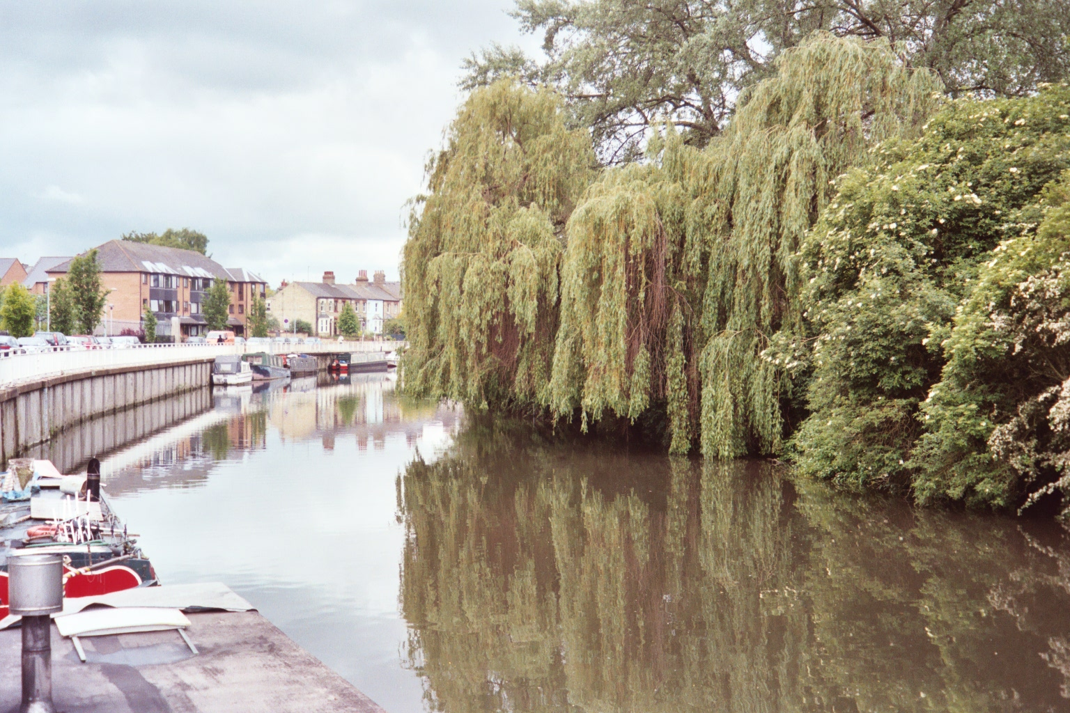

▲ View upstream from the Museum of Technology showing no mooring
zone along the old gasworks frontage. Tree reduction works would
increase channel width along the old Simoco site frontage but a habitat
and visual amenity corridor should be maintained as best as possible

Location | Lower River, between Elizabeth Way (A1134) road bridge and Stourbridge Common.
Length (approx.) | 600 metres
Structure | Riverside is a concrete retaining wall which carries the public highway some 1.5 metres above normal river retention level. There are metal railings along its length. The new Riverside Bridge (County Council) is due to be open in the spring of 2008. Its approach ramp commences in front of the Museum of Technology and crosses the river in an arc to meet the approach ramp on the Chesterton river bank across the old Simoco playing fields. No bridge abutments intrude into the river channel.
Navigation width | River channel width is mostly in excess of 20 metres along this reach.
Other navigation factors | Water depths along the length of the wall have become very shallow (less than 1m depth) in places; long-term mooring has led to the deposition of silt. The line of boats makes access to the safety chains along the length of the wall very difficult for any river user involved in an accidental immersion.
Ownership | The wall is maintained by Cambridgeshire County Council as a public highway.
Mooring arrangements | Mooring has been tolerated here for many years. The County Council has no inclination to enforce a ban at present. Conservancy signs are affixed to the wall and on posts on the opposite bank indicating zones where mooring is permitted and prohibited. Typically, thirty-five or more vessels moor along the length of the wall and these are of varying dimensions (length and beam). Riverside does not currently fall within the City Council’s Mooring Policy but many people mooring here are on the waiting list for City Mooring Licences.

2.2.1 The Conservators’ Mooring Policy along Riverside
The Conservators Mooring Policy effective from 1st October 2004 reads:

1) GENERALLY
Downstream of Victoria Bridge, prohibit ‘double parking’ anywhere along the river. This is to include the tying-up of a small dinghy or rowing boat on the outside of a moored craft, irrespective of the widths of any of the craft
and
6) ELIZABETH WAY BRIDGE TO GREEN DRAGON BRIDGE (partial excerpt)
Prohibit mooring along the right bank from the Eight’s Marina prohibition to opposite Priory Road.
Prohibit mooring along both banks for the length of the old gasworks frontage.
Prohibit mooring along the left bank for the length of the disused tennis courts and old Phillip’s boathouse frontage.

2.2.2 Navigation issues
In plan view the river snakes an S-shaped course, first bending to the right and then to the left as one progresses downstream. There are sightline issues for vessels because of these bends in the river. This reach is used mainly by rowing vessels and motorised vessels plus some racing kayaks. A 20 metre-wide navigation fairway can be maintained along the length of this reach but this can only be achieved if trees are trimmed back with no more than 1-2 metres overhang from the river bank. The willow trees along the Chesterton bank have been a cause for complaint since the Conservators’ first mooring review was put out to public consultation in 1997. Where the trees encroach into the navigation fairway, vessels are forced to move out into the centre of the channel, increasing the likelihood of collision.
The trees however, have a speed-regulating effect also. Vessels moving at lower speeds have a greater opportunity to avoid collisions. It is currently difficult for wide-beam motorised vessels and rowing eights to pass each other safely. Generally, one vessel must pull over to allow the other unrestricted passage. Loss of propulsion can create problems in high flows and strong winds. Any stoppages lead to congestion and further risk of collisions. Generally, rowing vessels prefer to navigate to a line of vessels of even width, so intermittent breaks in the line of moored vessels, as currently occurs, is not necessarily helpful to coxes and oarsmen.

2.4.7 Proposed modification to the Conservators’ Mooring Policy
The preferred option for consideration is given in the table below.

Proposal | Justification
Prohibit mooring along the right bank from the Museum of Technology to the end of Riverside and its junction of Stourbridge Common. Moorers using this frontage to be given notice to leave by 1st January 2009. | Traffic flow is affected by these moored vessels, increasing the risk of collision incidents. Moored vessels would be restricted to a single rank from Priory Road to the start of the old gasworks frontage (Riverside Place), potentially improving traffic flow, but 12 mooring spaces would be lost.

Comments on this option are sought.

___________________________________________________________________________________
2.3 Victoria Bridge to Eights Marina (Midsummer Common)

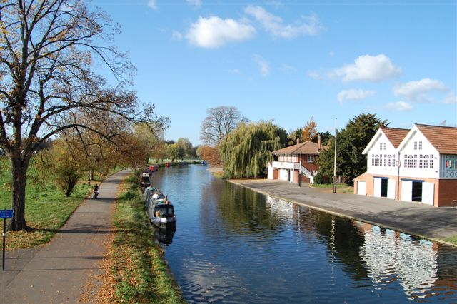

▲ View upstream from Cutter Ferry footbridge showing narrowboats
moored along the banks of Midsummer Common opposite the
boathouses.

Location | Lower River, comprising river banks adjacent to Midsummer Common from Victoria Avenue road bridge to Eights Marina upstream of Elizabeth Way (A1134) road bridge.
Length (approx.) | 800 metres
Structure | Hard piled riverbank with a fairly low freeboard.
Navigation width | The channel is of fairly constant width along these reaches (30 metres), allowing adequate room for two racing eights to pass each other unimpeded.
Other navigation factors | Many of the boathouses are located on the opposite bank. The low freeboard of the river bank can cause problems for moored vessels at times of flood when water levels are raised.
Ownership | The City Council is the riparian landowner.
Mooring arrangements | The Conservators’ mooring zone corresponds to Areas E1, E2, F, G and H of the City Council’s Mooring Policy. Mooring Licence Holders moor along the river bank here (approximately 20 vessels). City Council Zone E, in front of the Fort St George Public House, has been designated as a short-stay (48 hr) visitor mooring.

2.3.1 The Conservators’ Mooring Policy at Midsummer Common
At their meeting on the 14th April 2005 the Conservators agreed that a planned seasonal prohibition on mooring on Midsummer Common (1st October to 31st March annually) would be deferred for a further two years so that the effects of the City Council’s Mooring Policy could be monitored.
The original decision taken by Conservators in 2004 was for a seasonal ban, the Mooring Policy at that time reading as follows:

4) Victoria Bridge to Eights Marina.
Prohibit mooring along the right bank for a length of 80 metres downstream of the Fort St George Footbridge.
Downstream of the above length, prohibit mooring during the period 1st October to 31st March each year. At other times mooring in this section be restricted to 2.15 m width.

2.3.2 Navigation issues
There is some risk of collision when motorised vessels pull away from their moorings or when rowing boats set off from the boathouses on the opposite bank. The Conservators’ prohibition was due to be reinstated on 1st October 2007 if the City Council’s scheme was proven to be unsuitable or unsafe. At times when there are major rowing events, the City Council’s officers ask the owners of boats moored here to move on for the duration of the races. Most vessel owners comply and this arrangement appears to be working at present. The vessel width restriction has continued to apply and it is enforced.

2.3.7 Proposed modification to the Conservators’ Mooring Policy
The preferred option for consideration is given in the table below.

Proposal | Justification
Defer the planned seasonal prohibition for a further 2 or 3 years | The navigational reasons for prohibiting mooring have not been evident. The channel width is adequate along this reach (in excess of 20 metres). The City Council Mooring Policy is reviewed annually, at which time its effectiveness is available for review by the public, offering river users the opportunity to comment on the mooring arrangement here.

Comments on this option are sought.
___________________________________________________________________________________
2.4 Jesus Green Frontage

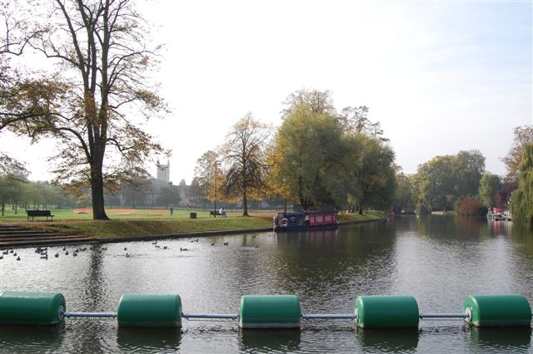

▲View upstream of Jesus Green Frontage from Jesus Sluices safety boom.
Note the presence of the illegally-moored narrowboat

Location | Middle River, between La Mimosa restaurant and Jesus Lock
Length (approx.) | 180 metres
Structure | Hard-piled river bank with concrete capping; grassy banks with a gentle incline leading to the public footpath. The landing area in front of Jesus Lock gates has a tarmac surface. There are steps leading up to the public footpath near the kiosk.
Navigation width | Over 40 metres along most of this reach.
Other navigation factors | None.
Ownership | This stretch of river bank is owned by Cambridge City Council as a continuation of Jesus Green. The Conservators have no riparian rights here.
Mooring arrangements | The Conservators prohibit mooring here at present but short-term mooring has been allowed for example, for people to enjoy picnics on the riverbanks. Generally, boats do not remain here overnight. The City Council’s Mooring Policy prohibits the use of the Frontage for the purpose of commercial punt operation without the express written consent of the Council.

2.4.1 The Conservators’ Mooring Policy along Jesus Green Frontage
Paragraph 2(d) of the Conservators’ Mooring Policy reads:

Prohibit mooring along Jesus Green Frontage.

Also, Paragraph 1 applies to this area: Prohibit mooring within 36 m of any lock, sluice, weir or water intake (to comply with Byelaw 6.7).

2.4.2 Navigation issues
Providing that the entry to the lock is not impeded, there are no real navigation issues because the river is wide and visibility is good. This reach is used mostly by small craft (punts, rowing boats, canoes and kayaks). Motorised vessels are prohibited from 1st April to 30th September inclusive and outside these dates, motorised traffic through Jesus Lock up to Byron’s Pool is controlled by the Control Officer (Byelaw 5.1). Five residential boats have been allowed to moor on the opposite bank at Jubilee Gardens (City Council Mooring Zone B). These vessels move through the lock to use the Jesus Green pump-out station on a regular basis. They require a certain turning area (at least one vessel length, or 20 metres) to manoeuvre on and off their moorings. There is a large safety boom across the front of the sluices, maintained by the Environment Agency, to prevent vessels from being swept onto the weir.

2.4.3 Proposed modification to the Conservators’ Mooring Policy
The preferred option for consideration is given in the table below.

Proposal | Justification
Lift the prohibition on mooring (excepting the 36 m Byelaw limit upstream of Jesus Lock) | The original proposal presented to Conservators in 2004. The navigation width is suitable for all vessel categories. The number of motorised craft using this reach is well controlled by the seasonal prohibition on motorised craft.

Comments on this option are sought.

___________________________________________________________________________________
APPENDIX 1: CONSERVATORS’ MOORING POLICY

A1.1 Mooring Policy to Take Effect from 1 October 2004

CONSERVATORS OF THE RIVER CAM

RESTRICTIONS ON MOORING (FOR NAVIGATIONAL REASONS)

MOORING POLICY TO TAKE EFFECT FROM 1 OCTOBER 2004

(CAME INTO FORCE 18 JUNE 1998
REVIEWED WITHOUT CHANGE 6 JULY 2000
REVISED 1 JULY 2004 and AMENDED 23rd SEPTEMBER 2004)

In the following left and right bank are viewed looking downstream.

- GENERALLY

Prohibit mooring within 36 metres of any lock, sluice, weir or water intake. (This to comply with Byelaw 6.7)

Downstream of Victoria Bridge, prohibit ‘double-mooring’ anywhere along the river. This is to include the tying up of a small dinghy or rowing boat on the outside of a moored craft, irrespective of the widths of any of the craft.

2) ABOVE JESUS LOCK (note: motorised craft are only permitted to navigate above the Jesus Green frontage during the period 1st October to 31st March each year)

- Upstream of Quayside

During the period 1st October to 31st March mooring be permitted in the Mill Pond only

At all other times prohibit mooring on both sides apart from the punt stations.

- Quayside

Prohibit mooring along both banks apart from at the punt stations

- Riverside Walkway

Prohibit mooring along both banks save for those boats in registration categories 1-12 and at the punt station at the Public House.

- Jesus Green & Jubilee Gardens

Prohibit mooring along the Jesus Green frontage

If finger mooring is ultimately adopted along Jubilee Gardens, this to be of chevron format and extend no further than 18m out from the bank.

- JESUS LOCK TO VICTORIA BRIDGE

No restriction apart from a localised length of 40m on the right bank to facilitate use of the pump out station.

Elsewhere moored craft to be restricted to 4.3 m in width, which may be two craft moored alongside each other.

Sufficient short stay mooring be provided in this area for visiting craft.

- VICTORIA BRIDGE TO EIGHTS MARINA

Prohibit mooring along the right bank for a length of 80 metres downstream of the Fort St George Footbridge.

From 1st October 2005, Downstream of the above length, prohibit mooring during the period 1 October to 31st March each year. At other times, mooring in this section to be restricted to 2.15m width.

- ELIZABETH WAY BRIDGE

Prohibit mooring along both banks for the length of the Eights Marina frontage

- ELIZABETH WAY BRIDGE TO GREEN DRAGON BRIDGE

Prohibit mooring along the right bank from the Eight’s Marina prohibition to opposite Priory Road

Prohibit mooring along both banks along the old gasworks frontage.

Prohibit mooring along the left bank for the length of the disused tennis courts and old Philips boathouse frontage.

Mooring along Stourbridge Common from Riverside to Green Dragon Bridge be restricted to 2.15m width.

- GREEN DRAGON BRIDGE

Prohibit mooring along the right bank for approx 120m along the length of the curve at the bridge

8) GREEN DRAGON BRIDGE TO UPSTREAM END OF TOWPATH

Prohibit mooring along the right bank

- UPSTREAM END OF TOWPATH TO BAITS BITE LOCK

Prohibit mooring along the left bank (the towpath)

Prohibit mooring along the right bank at the railway bridge

Prohibit mooring along both banks at the ‘change over points’ by Grassy Corner, together with Ditton narrows and the bend.

- BAITS BITE LOCK TO BOTTISHAM LOCK

Prohibit mooring along the left bank (the towpath) downstream as far as 100m from Clayhithe Bridge. Mooring in this 100m length to be for 48hr maximum duration.

Prohibit mooring along the right bank opposite the motor boat and sailing clubs.

Geoff Facer
Engineer & Control Officer
October 2004

A1.2 Amendments to the Mooring Policy effective from 1 October 2004

CONSERVATORS OF THE RIVER CAM

RESTRICTIONS ON MOORING ( FOR NAVIGATIONAL REASONS )

MOORING POLICY EFFECTIVE FROM 1 OCTOBER 2004

At their meeting on 23rd September 2004 Conservators agreed the following amendments to the previously published mooring policy :-

Para 2 (c) Riverside Walkway

To read ‘ prohibit mooring along both banks save for those boats in registration categories
1 –12 and the punt station at the public house’

Para 4) VICTORIA BRIDGE TO EIGHTS MARINA

The seasonal prohibition on mooring ( 1 October to 31st March ) is deferred for one year and is now to commence 1 October 2005

The Conservators agreed the change at para 4) above in consequence of an undertaking from the City Council Leader to progress that Council’s own review of river mooring and to produce its own mooring policy before 1 October 2005. Conservators also agreed to review their policy in the light of what transpires from the City Council’s proposals. Thus further changes to the Conservancy Mooring Policy may take place within the next twelve months.

Geoff Facer
Engineer & Control Officer
September 2004

APPENDIX 2: MOORING AND THE STATUTORY POWERS OF THE CONSERVATORS

A2.1 Definition of mooring
The act of mooring is not defined explicitly in the 1851 and 1922 Acts for the River Cam, so the normal (common) use of the word would prevail. Mooring (verb) is the act of making a vessel fast, i.e. a vessel is said to be moored when it is fastened to a fixed object such as a pier or quay, or to a floating object such as an anchor buoy for any length of time. The vessel must be tied up, by means of ropes, chains or cables, for it to be moored. If someone is ashore holding a line in their hands without being tied-up, this would not meet the definition of being ‘made fast’.

A2.2 Statutory powers of the Conservators
The Conservancy has the general right to prohibit mooring where it interferes with navigation. In addition, the Conservancy has powers as a riparian landowner (e.g. the Halingway towpath) to decide where mooring may take place.
The statutory basis (Acts and Byelaws) underpinning the Conservators’ Mooring Policy can be found in Section 36 of the River Cam Navigation Act 1851 (“… that it shall be lawful for the Conservators … to maintain navigable the said river…”). Also, Section 25(1) of the River Cam Conservancy Act 1922 states that “The Conservators may from time to time make such bye-laws applicable within the Cam Conservancy Area as they think fit for all or any of the following purposes namely:- (a) For the regulation and management of the rivers and waters within the Cam Conservancy area and the navigation thereof and for the prevention of obstructions to such navigation; … “
Byelaw 6 sets out the terms on which persons may moor their vessels in the Cam Conservancy Area. The two most pertinent clauses are:
Byelaw 6.1: “No person shall put out or affix any mooring for or from any vessel to a bank of the River or erect any landing plank or structure from any vessel in such a manner as to impede or obstruct with the free passage of persons or vehicles over and along the bank.”; and
Byelaw 6.2: “The master of any vessel shall not cause or permit such vessel to be moored at any wharf or any mooring place on the River unless such vessel shall be securely moored head and stern, shall be laid as close to and along the side or front of such wharf or mooring place as may be convenient, and shall be so moored as not to cause any obstruction to the navigation of other vessels save with the written consent of the Control Officer subject to such conditions as the Control Officer may impose.”

Registration categories 1-12 are all manually-propelled small craft, including canoes and kayaks, rowing dinghies, standard and wide-beam punts.

